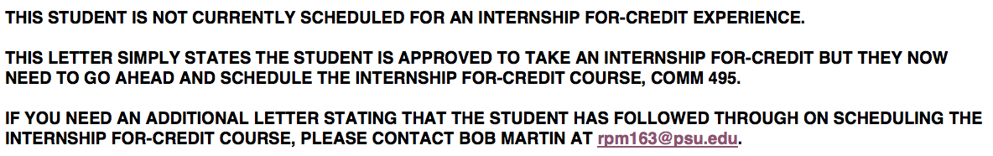

<<Month Day, Year>>

<<Name of Company>>
<<Contact Person>>
<<Contact Person’s Title>>
<<Street Address>>
<<City, State Zip Code>>

Dear <<Mr/Ms.>> <<Last Name>>:

This letter is to verify that <<insert your first and last name here>> is a <<current semester
standing>> semester student in good academic standing and has been approved to take an internship
for <<# of credits >> credit with <<Company Name>> through the Donald P. Bellisario College of
Communications at Penn State University during <<semester>> of <<year>>.

Students receiving academic credit must complete a minimum of 67 hours of work per credit
(<<Your first name>>is taking the internship for << # of credits>> credit; therefore he/she must work a minimum of <<67 X #of credits>>hours). <<your first name>> is prepared to exceed this amount if the minimum number of hours required by your organization is higher than the hours required by our College.

Thank you for partnering with Penn State’s Donald P. Bellisario College of Communications and our
students and being an integral part of the success of our internship program. If you have any additional
questions, please feel free to contact me at (814) 863-4674.

Sincerely,

Robert P. Martin
Assistant Dean for Internships and
Career Placement

